PIF Creation Process

PIF creation process has been changed to automatic creation to user request process.

Whenever any user wants to download any PIF file, they need to request the PIF files through the below mentioned process to ensure that they always get the latest PIF files.

# Process to request for PIF Files

Step 1: Login into DCAT Application.

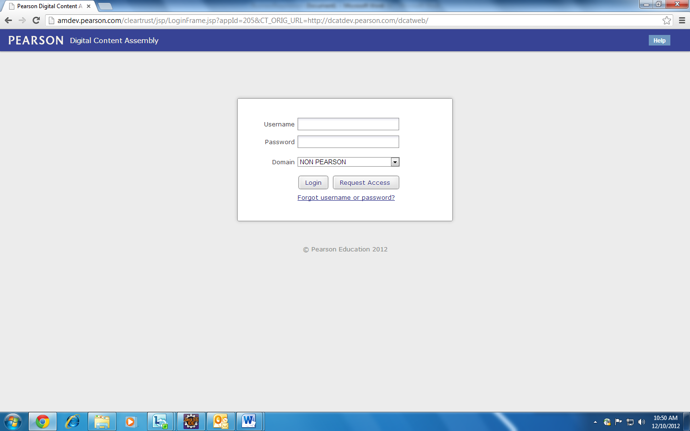

Step 2: Enter the Username and Password (the user which exists in DCAT) and then click on Login Button to login into DCAT Application.

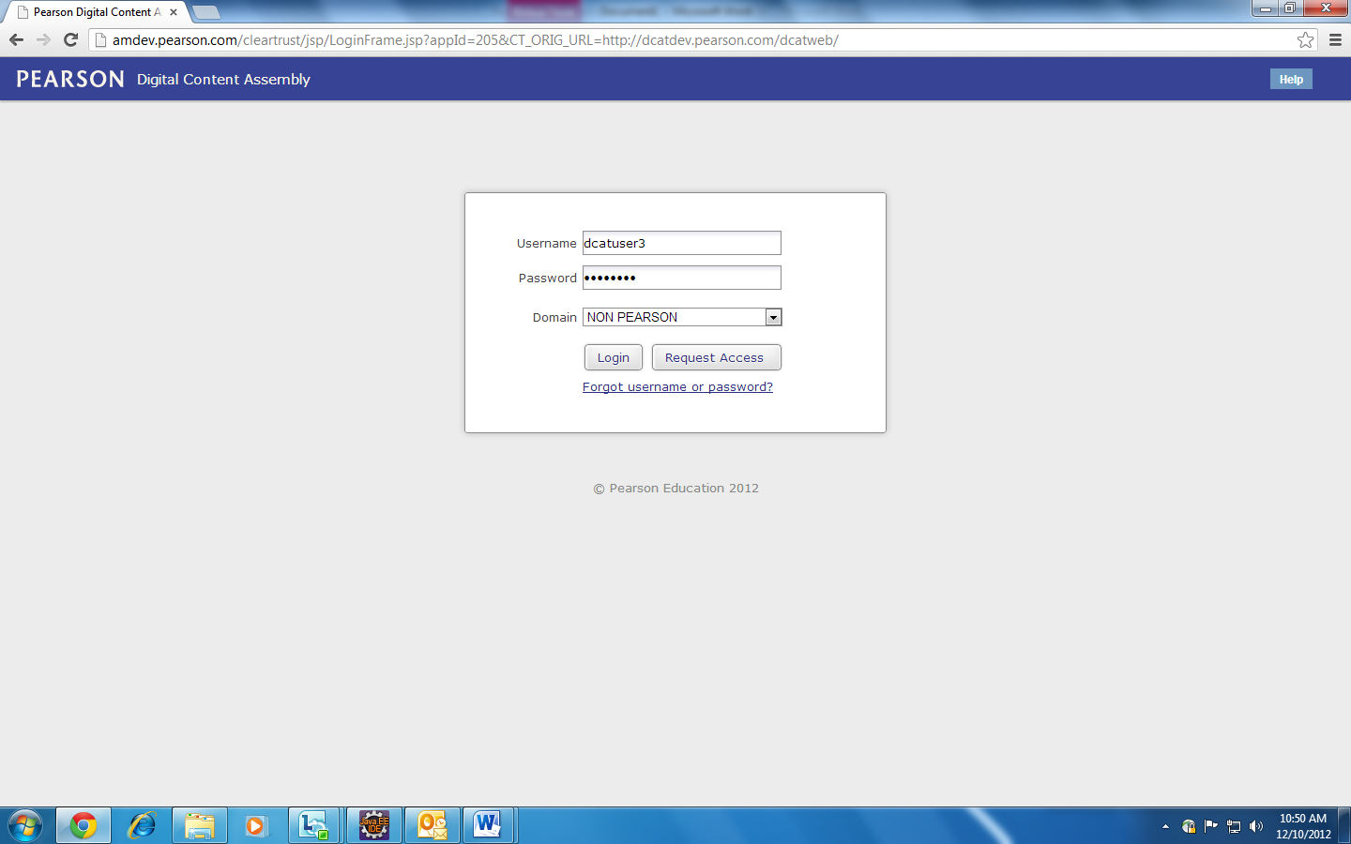

Step 3: Click on any project to go to the Home Screen of the project.

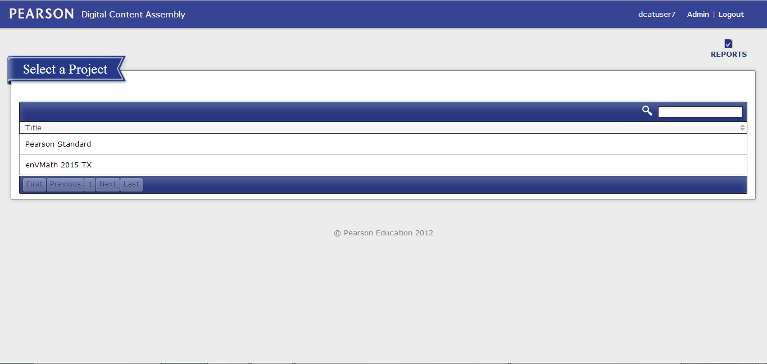

Step 4: Click on Publish link in the header which is in between of “Home” and “My Projects” link.

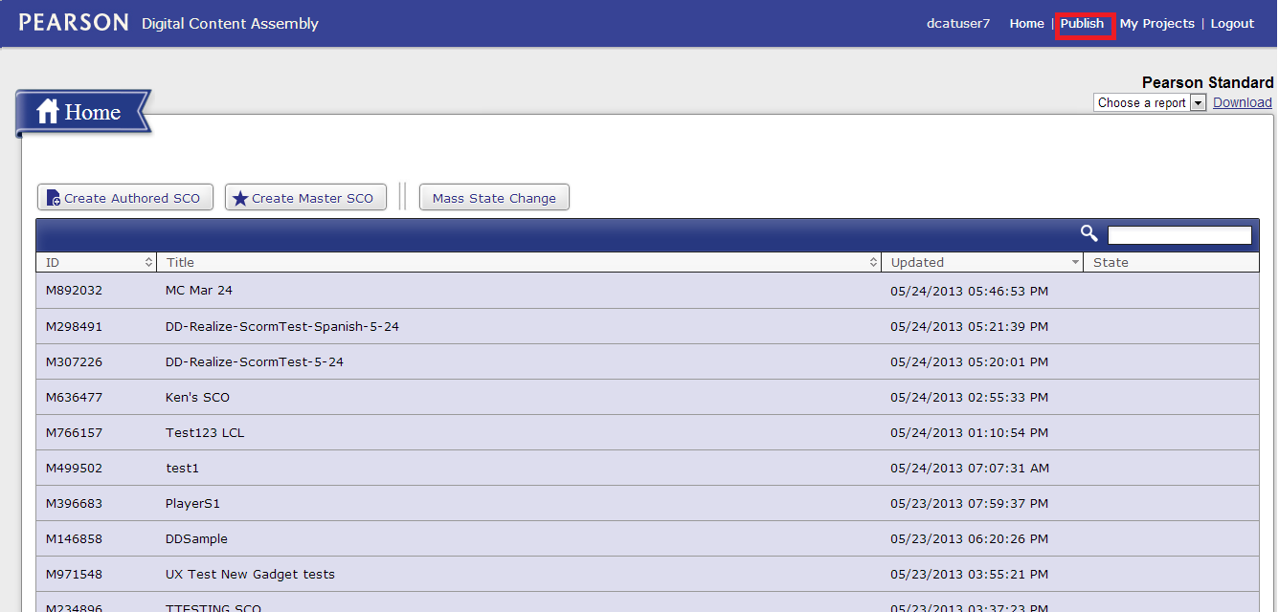

Step 5: Select the SCOs for which PIF files needed to be created.

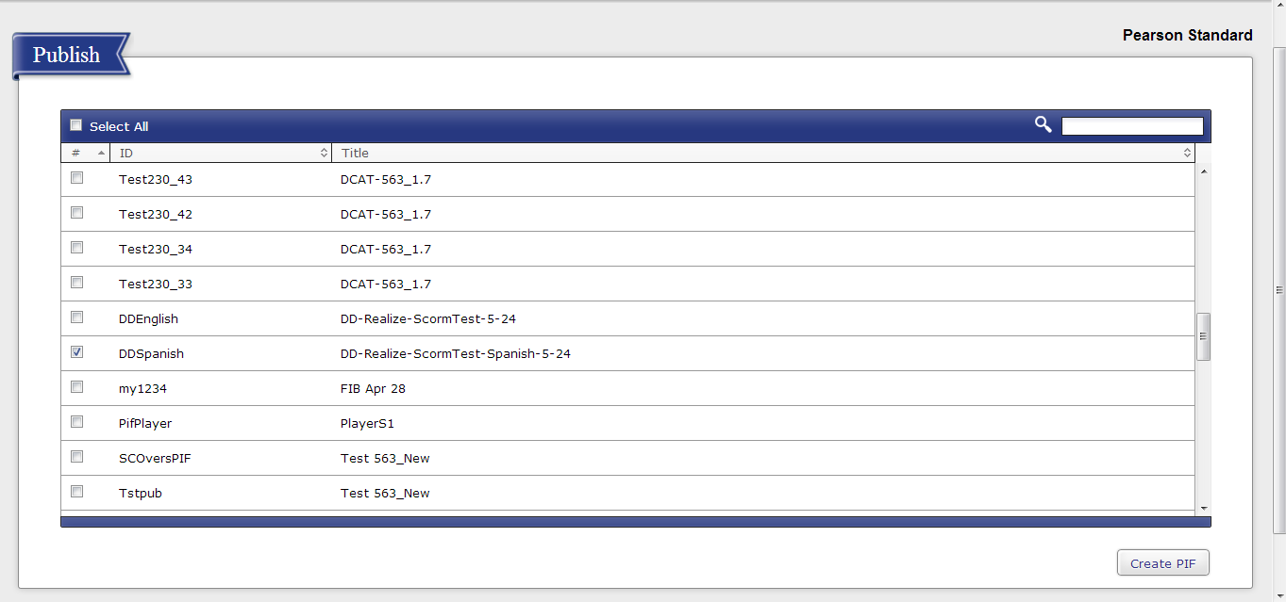

Step 6: Click on “Create PIF” button at the bottom to request for the PIF files and would get a confirmation message to know that your request has been sent for processing.

In case any error occurred, “Something Went Wrong” message would be displayed.

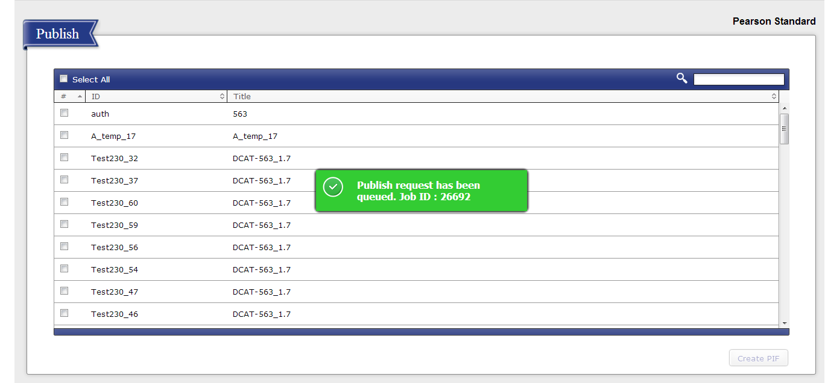

Step 7: User would get an email confirmation in their mailbox to know that the request has been processed. Confirmation email would contain the PIF report for the SCOs for which PIF files have been successfully created.

Email Format:

